Q9 Create a simple cloud software application for Hospital information system for

SIMATS Hospital using any Cloud Service Provider to demonstrate SaaS with

fields of patient name, age, address, phone, email, Attender name, attender

phone, doctor name, diseases, etc

# CREATING THE USER INTERFACE  
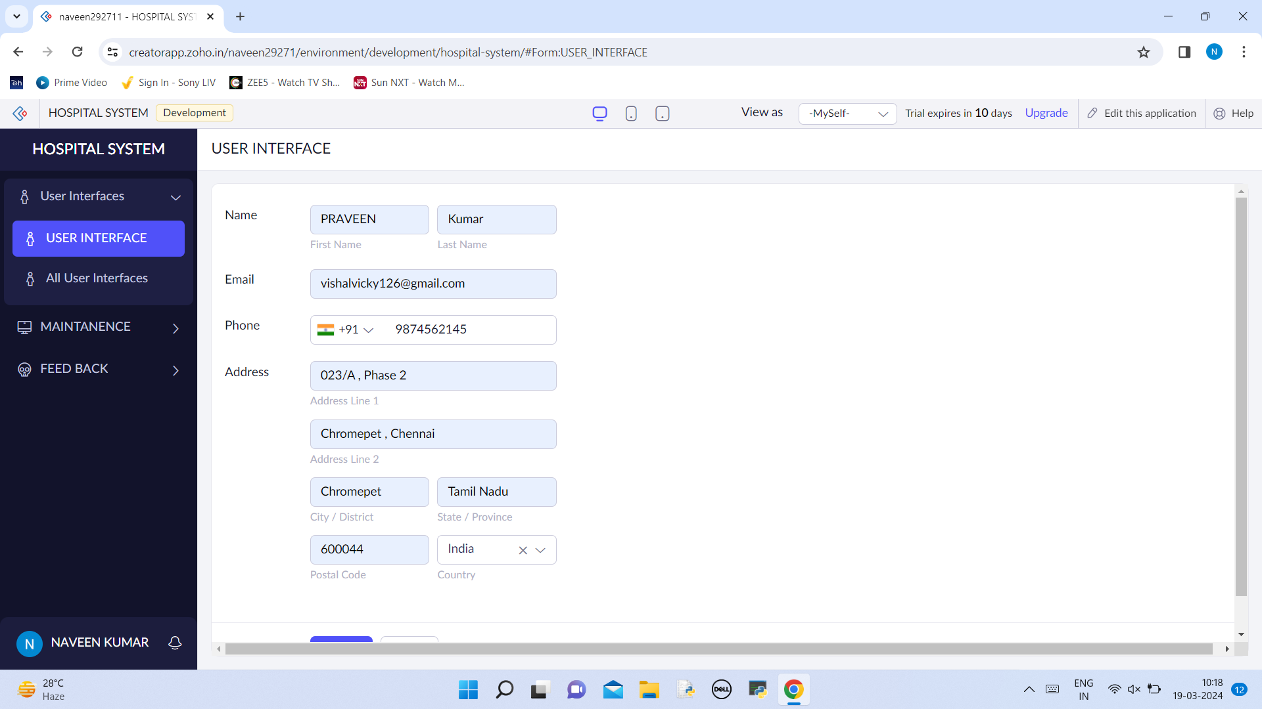

# LISTING THE USER INTERFACE  
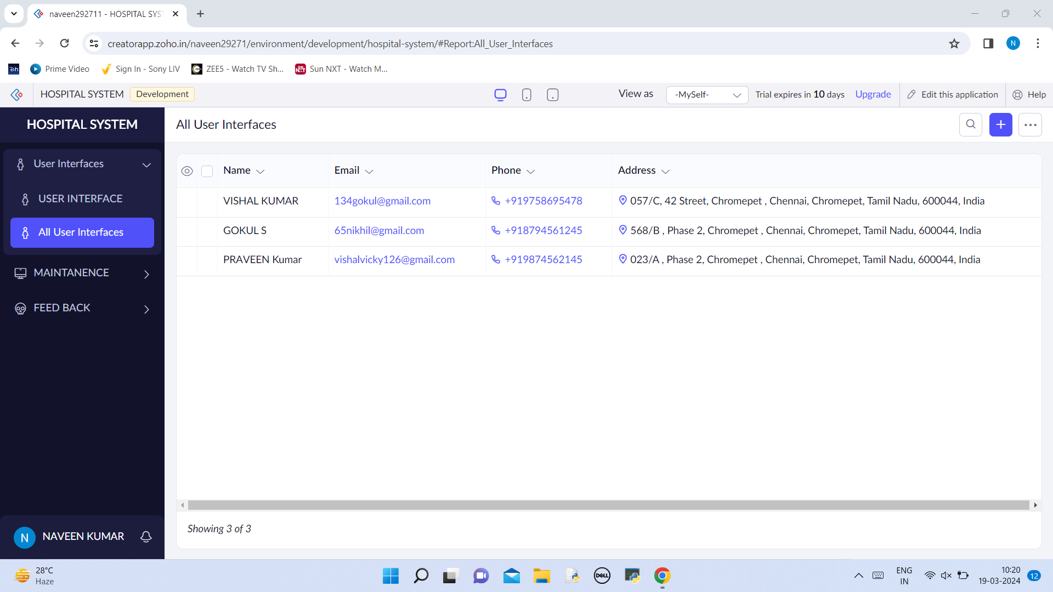

# CREATING THE MAINTENCE OF THE HOSPITAL   
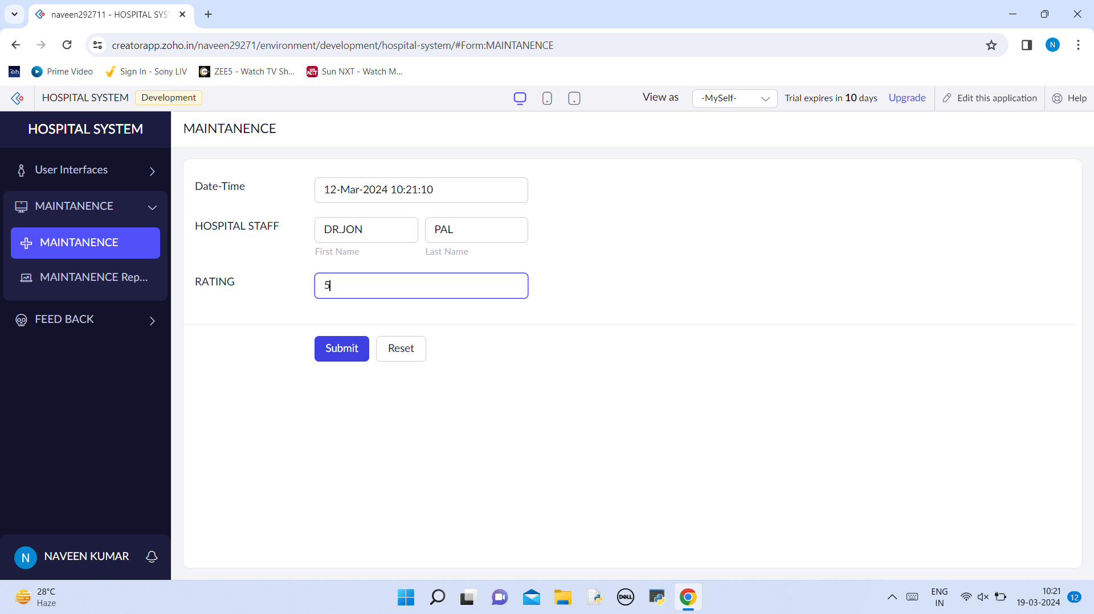

# LIST OF MAINTANENCE   
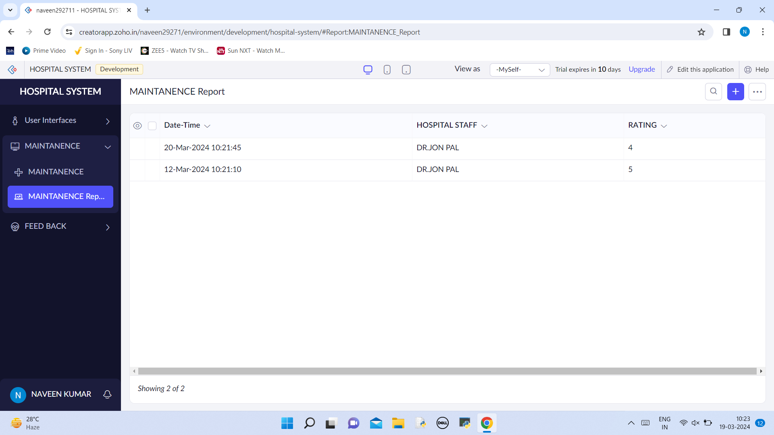

# FEED BACK TO BE CREATED   
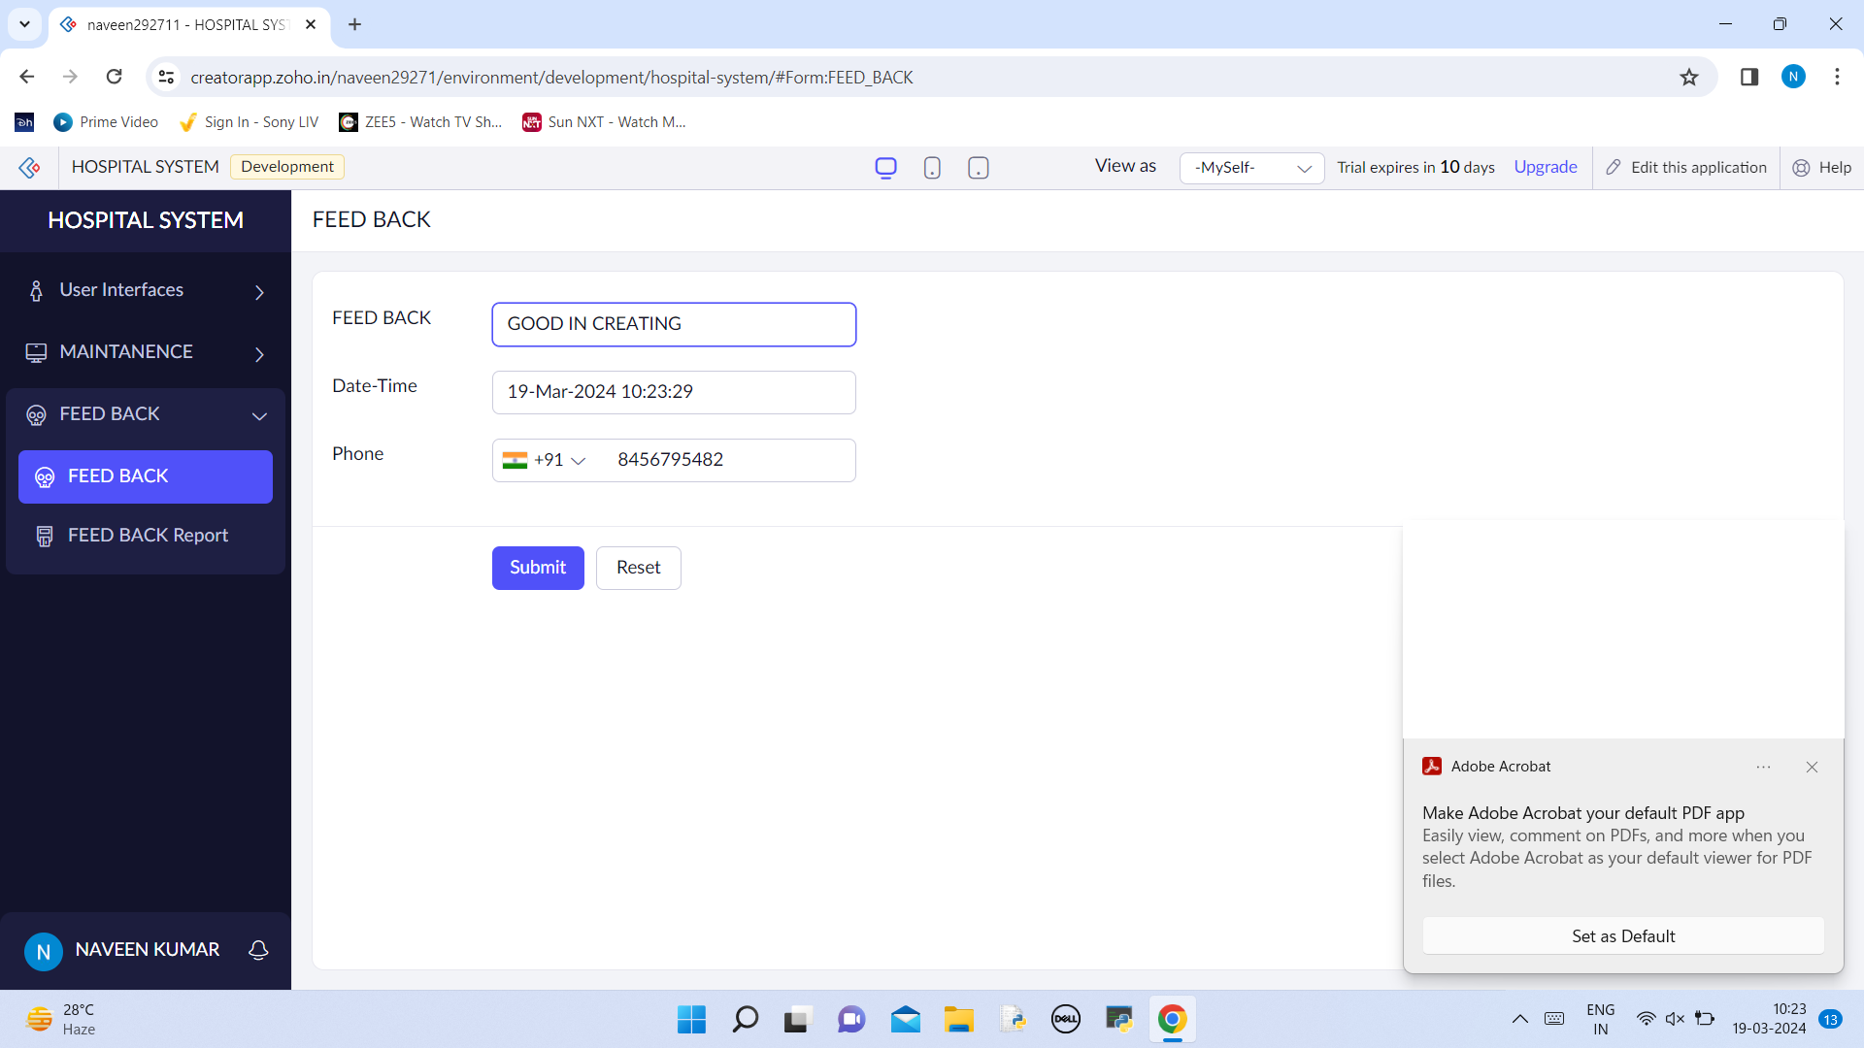

# LIST OF FEEDBACK  
